Risk–benefit data
Provided to assess the risk-benefits of catching and/or dying from Covid-19 versus
injury and/or death from provisionally approved Covid-19 vaccines for a woman in
the 70–79 age bracket living in the Australian Capital Territory as at 17 March 2022.

Covid-19 Mortality in Australia
https://www.abs.gov.au/articles/covid-19-mortality-australia released 15 Feb 2022

Of the total 273,901 death registrations received by the ABS and certified by a doctor in Australia for the two-year period from January 2020 to 31 January 2022,
- 2,556 deaths were from COVID-19, approx 1% of total deaths (Screenshot 1); and
- 208 deaths were of women in the 70–79 age bracket who have died from Covid-19, approx 0.076% of total deaths in the period (Screenshot 2); and
- 16 deaths from Covid-19 were in the ACT, approx 0.0058% of all total deaths in the period (Screenshot 2).

When taking into account that 17 deaths were recorded with the World Health Organization code U07.2 (suspected or clinical diagnoses of COVID-19 where testing is not completed or inconclusive) the percentage of Covid-19 deaths is 0.92% of total deaths.

When taking into account that pre-existing conditions were reported on death certificates for 1,776 (69.5%) of the 2,556 deaths due to Covid-19 (Screenshot 3), the percentage of Covid-19 deaths is 0.28% of total deaths.

When taking into account that 91.4% of the 2,556 deaths due to Covid-19 registered with the ABS had other conditions listed on the death certificate (Screenshot 4), the total number of death registrations from Covid-19 only is reduced to 220 deaths, the percentage of Covid-19 deaths is 0.08% of total deaths in Australia for the two-year period from January 2020 to 31 January 2022.

Covid-19 testing and cases*
https://www.health.gov.au/health-alerts/covid-19/case-numbers-and-statistics

Two-year period from approx late January 2020-February 2022
- Total tests: 64,155,125 (Screenshot 5)
- Total cases: 3,039,280, 4.7% of total number tested (Screenshot 6)
- Total cases ACT: 55,321, 0.086% of total number tested (Screenshot 6)
- Total cases females 70–79: 29,726, 0.046% of total number tested (Screenshot 7)

ACT aged-care homes (Screenshot 8)
- 186 active and recovered cases, 0.0061% of total 3,039,280 cases
- 16 deaths, 0.00053% of total 3,039,280 cases

*These data appear on the Australian Department of Health website and are sourced from the National Notifiable Disease Surveillance System (NNDSS) data dated 8 March 2022. However, these data cannot be verified or interrogated as the NNDSS is currently being decommissioned and replaced. Note that the Department of Heath death records, which cannot be interrogated, do not correspond with the ABS officially recorded deaths, which have been certified by a doctor (see above). https://www1.health.gov.au/internet/main/publishing.nsf/Content/ohp-pub-datasets.htm

Covid-19 Recovery Rate

Total recorded deaths 2,556 from Covid-19 as a percentage of the total recorded Covid-19 cases (3,039,280 see Screenshot 8) can be calculated to be 0.084%, which is a recovery rate from Covid-19 of 99.91%.

Total recorded deaths adjusted 220 from Covid-19 for people with no other health condition recorded on the death certificate, as a percentage of the total recorded Covid-19 cases (3,039,280 see Screenshot 8) can be calculated to be 0.007%, which is a recovery rate from Covid-19 of 99.993%.

TGA Covid-19 Vaccines Database of Adverse Events Notifications https://apps.tga.gov.au/PROD/DAEN/daen-new-search.aspx

The Australian Department of Health reports that:
- 19,888,505 people have had at least one dose; and
- 19,511,428 (94.6% of those aged 16 or more) are fully vaccinated.
(Screenshot 7) https://www.health.gov.au/sites/default/files/documents/2022/03/covid-19-vaccine-rollout-update-8-march-2022_0.pdf
All four Covid-19 vaccines – COMIRNATY (Pfizer) mRNA COVID-19 vaccine, COVID-19 Vaccine Vaxzevria AstraZeneca, NUVAXOVID (Novavax NVX-CoV2373) Covid-19 Vaccine, and Spikevax (Moderna) mRNA COVID-19 vaccine are only provisionally approved.
During a one-year period from 22 February 2021 to 3 March 2022, the following is recorded (Screenshot 10) https://apps.tga.gov.au/PROD/DAEN/daen-new-search.aspx:
- 114,124 (0.578%) of those so far injected had recorded adverse events; and
- 783 (0.004%) of those so far injected had died.
Note that the Therapeutic Goods Administration (TGA) states on its website “It is generally acknowledged that adverse events are under-reported around the world, with estimates that 90-95% of adverse events are not reported to regulators.
In recent years evidence has emerged that adverse event reports from consumers contain information that is useful for monitoring the safety of therapeutic products, but there is low awareness of available reporting systems.” (Red bold added, Screenshot 11) https://www.tga.gov.au/media-release/new-web-service-helps-consumer-reporting-side-effects
Personal first-hand vaccine injury reports available https://t.me/covidvaccineinjuries

Covid-19 hospitalisation post vaccination
The NSW Government Covid-19 Weekly Surveillance Report published on 4 February 2022, shows that the vaccinated population accounted for 90% of hospitalisations in New South Wales between 26 November 2021 and 8 January 2022.
This report shows that in New South Wales, there were a total of 3,022 hospitalisations (excluding aged 0-11 years not eligible for vaccination and those whose status is under investigation). Of these 3,022 hospitalisations, 315 were not-vaccinated, 80 were partly vaccinated, and 2,627 were fully vaccinated. (Screenshot 12) https://www.health.nsw.gov.au/Infectious/covid-19/Documents/covid-19-surveillance-report-20220120.pdf
Based on 94.4% of people in New South Wales being fully vaccinated (Screenshot 13) https://www.health.nsw.gov.au/news/Pages/20220311_00.aspx, this data supports the conclusion that Covid-19 vaccination has conferred a marginal 4.4% advantage against hospitalisation.
Rates of vaccination and death from Covid-19 in the ACT
As at 15 June 2020, with the ACT’s primary vaccination coverage at 0.0%, the ACT recorded 3 deaths from Covid-19. (Screenshot 14) https://www.parliament.act.gov.au/__data/assets/pdf_file/0003/1562916/Chief-Health-Officer-Report-on-Status-of-Public-Health-Emergency-Due-to-COVID-19-15-June-2020.PDF
As at 3 February 2022, with the ACT’s primary vaccination coverage at 98.6%, the ACT recorded 34 deaths from Covid-19 (Screenshot 15) https://www.covid19.act.gov.au/__data/assets/pdf_file/0011/1964873/Weekly-epidemiological-update-1-to-6-March-2022.pdf
Even when using the Australia Bureau of Statistics (Screenshot 2) record of 16 deaths from Covid-19 in the ACT to 31 January 2022, the increase in Covid-19 deaths in the ACT since the introduction of the Covid-19 vaccine appears disproportionate and counterintuitive, and raises questions.
COVID-19 vaccine claims scheme
In Australia, Covid-19 vaccine manufacturers have full indemnity, including a guarantee they are not liable for any deaths, diseases, or disabilities caused by the use of their products. For the first time, the Australian Government established a vaccine claims scheme, acknowledging there is risk of injury from Covid-19 vaccinations. (Screenshot 16) https://www.health.gov.au/initiatives-and-programs/covid-19-vaccine-claims-scheme.
The United States has operated the National Vaccine Injury Compensation Program (VICP) since 1988, and as of 3 January 2022, this program has paid out US$4.36 billion in compensation plus another almost half a billion dollars in legal fees paid out. (Screenshot 17) https://www.hrsa.gov/sites/default/files/hrsa/vaccine-compensation/data/vicp-stats-03-01-22.pdf
The list of adverse events listed by the Australian Government for claims purposes under the scheme include the following clinical conditions as follows: anaphylactic reaction, thrombosis with Thrombocytopenia Syndrome, myocarditis, pericarditis, capillary leak syndrome, demyelinating disorders including Guillain Barre Syndrome (GBS), Thrombocytopenia, including immune Thrombocytopenia.
Pfizer documents made public

On 1 March 2022, the US Food and Drug Administration complied with a Court order to begin releasing approximately 400,000 pages of Pfizer documentation, which Pfizer had sought to suppress until 2097.

One of these – 5.3.6 Cumulative Analysis of Post-authorization Adverse Events Reports – reports that within the first 90 days from the receipt of the first temporary authorisation for emergency supply of the Pfizer-BioNTech COVID vaccine (1 December 2020 – 28 February 2021):

- 1,223 vaccine-related deaths occurred; and
- 42,086 adverse event cases were reported.

(Screenshot 18 and page 7 of complete document here: https://childrenshealthdefense.org/wp-content/uploads/5.3.6-postmarketing-experience.pdf).

This document also reveals nine pages (Appendix 1 pp 30–38) of adverse events of special interest, including Covid-19 observed during that same period.
(Screenshot 19) Full document at https://childrenshealthdefense.org/wp-content/uploads/5.3.6-postmarketing-experience.pdf).

Pfizer had sought to prevent this document and hundreds of others from being publicly released until 2097. Currently, some 150 documents that the public can now download here.

Pfizer Covid-19 Vaccine Still in Clinical Trial

The Pfizer BioNTech* Covid-19 vaccine is still in its clinical trial phase, with an estimated study completion date of 8 February 2024 (Screenshot 20) https://clinicaltrials.gov/ct2/show/NCT04368728 Other Covid-19 vaccine trials can also be found on this site using the search function.

*The US Food & Drug Administration notes the Pfizer BioNTech Covid-19 vaccine will be now be marketed as Comirnaty. (Screenshot 21) https://www.fda.gov/emergency-preparedness-and-response/coronavirus-disease-2019-covid-19/comirnaty-and-pfizer-biontech-covid-19-vaccine#comirnaty

Additional information available on request
A thousand peer reviewed studies questioning Covid-19 vaccine safety are available here https://www.informedchoiceaustralia.com/post/1000-peer-reviewed-studies-questioning-covid-19-vaccine-safety.
Note this summary does not address data associated with evidence of the isolation of the SARS-CoV-2 virus (aka Covid-19), or the associated testing regimes such as the polymerase chain reaction (aka PCR), which raise additional questions.
Conclusion
The officially published data provided here – a miniscule fraction of what is readily available – indicates that the benefits being claimed for Covid-19 vaccinations do not match the available real-world data. The following specific evidence:
- the risk of someone living in an aged-care facility in the ACT catching Covid-19 has been 0.0061% over a two-year period; and
- the risk of someone living in the broader ACT community catching Covid-19 has been 0.086% over a two-year period; and
- the risk of death to a woman in the 70-79 age bracket from Covid-19 has been 0.076% over a two-year period; and
- the increase from three Covid-19 deaths with 0.0% vaccination rate to 34 deaths from Covid-19 in the ACT with a 98.6% Covid-19 vaccination coverage; and
- the overall Covid-19 recovery rate in Australia has been at least 99.91% over a two-year period; and
- the risk of an immediate to short-term adverse event after having a Covid-19 vaccine has been 0.578% over a one-year period;
- the risk of medium and long-term adverse events after having a Covid-19 vaccine is unknown; and
- all four Covid-19 vaccines are only provisionally approved; and
- the Pfizer Covid-19 vaccine is in Clinical Trial until February 2024; and
- official Pfizer Covid-19 Clinical Trial documents list hundreds of known adverse events of special interest, including Covid-19
supports the conclusion that a reasonable course of action is to wait until the completed Covid-19 vaccine clinical trial data are analysed before administering Covid-19 vaccines to a woman in the 70-79 age bracket living in the Australian Capital Territory.
Questions to ask Ahpra registered health practitioners
- Have you seen these data?
- Do you consider these data to be true and accurate?
- Has your registering body The Australian Health Practitioner Regulation Agency (Ahpra) in any way given you guidance, instructions, or any other form of direction in regards to what you can/cannot say about Covid-19 vaccinations?
  - (If yes) If you step outside those guidelines or instructions, do you risk being suspended, deregistered, or otherwise reprimanded or penalised for doing so?
  - (If no) What is your opinion of the safety and efficacy of the Covid-19 vaccinations?
- How much are you paid to recommend and/or administer each Covid-19 vaccine?
- Have any of your patients personally experienced any adverse reaction following a Covid-19 vaccine administered by you?
- (If yes) Did you or that patient register their adverse reaction with the TGA Database of Adverse Event Notifications (DAEN)?
- (If yes) How did you find that process (for example, time-consuming, easy, confusing, trouble-free, anything else)?
Screenshot 1 https://www.abs.gov.au/articles/covid-19-mortality-australia
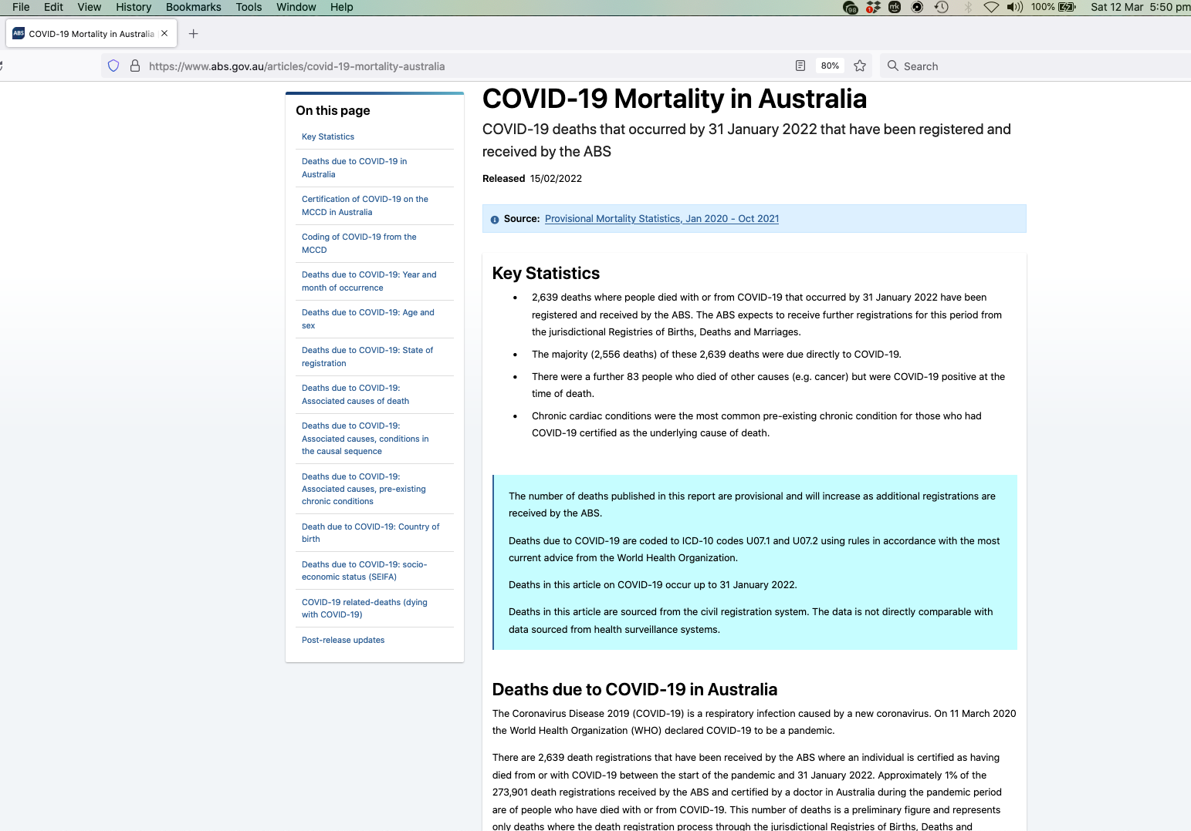

Screenshot 2 https://www.abs.gov.au/articles/covid-19-mortality-australia

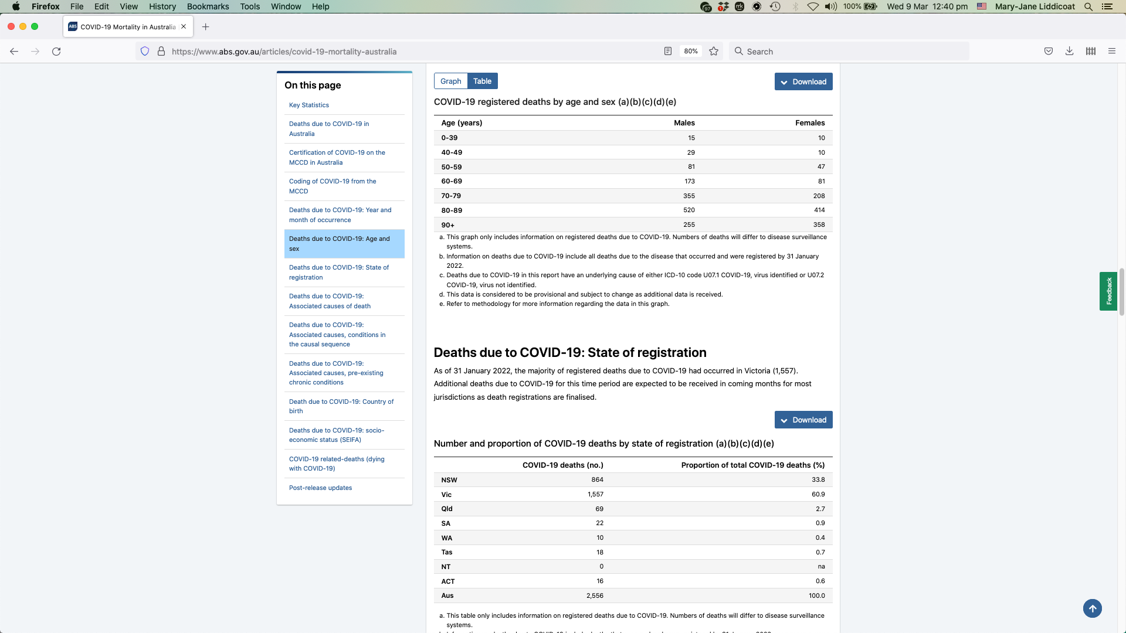

Screenshot 3 https://www.abs.gov.au/articles/covid-19-mortality-australia

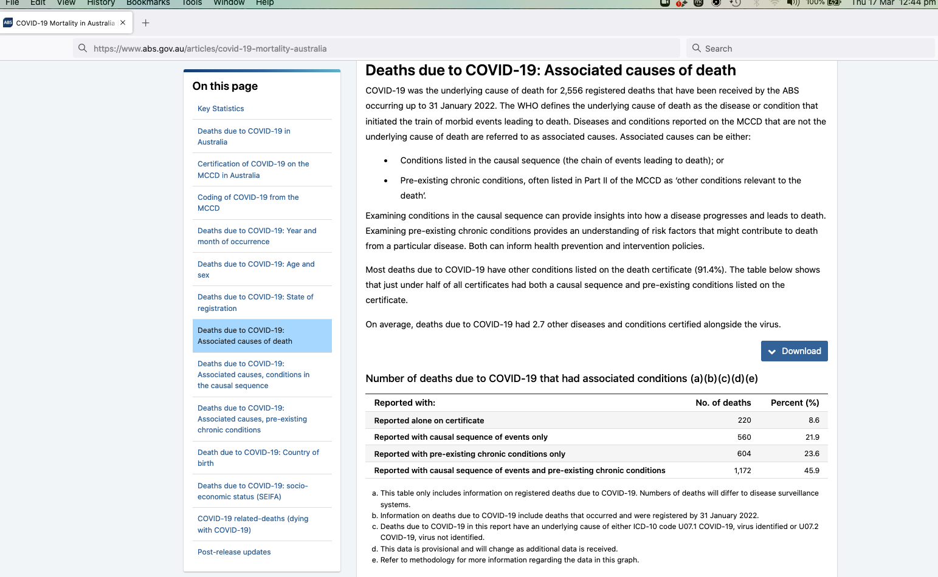
Screenshot 4 https://www.abs.gov.au/articles/covid-19-mortality-australia

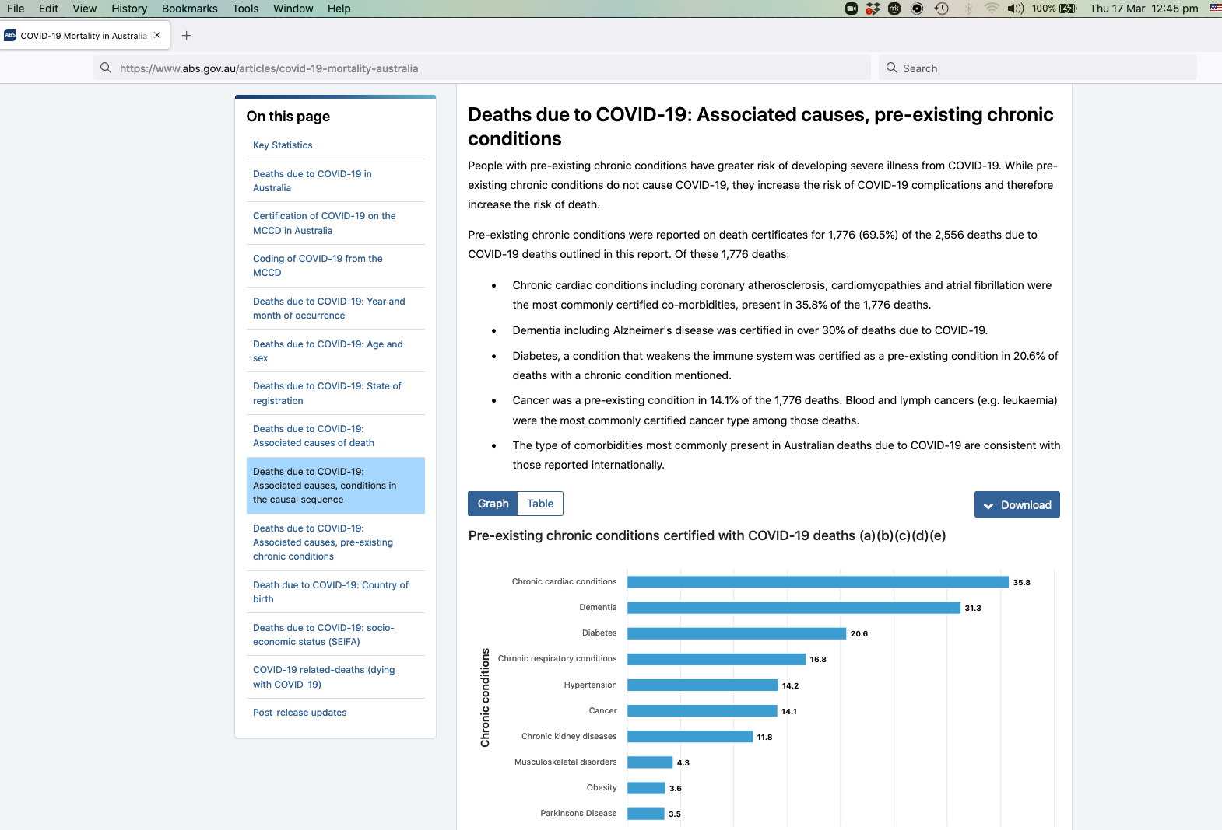
Screenshot 5 https://www.health.gov.au/health-alerts/covid-19/case-numbers-and-statistics

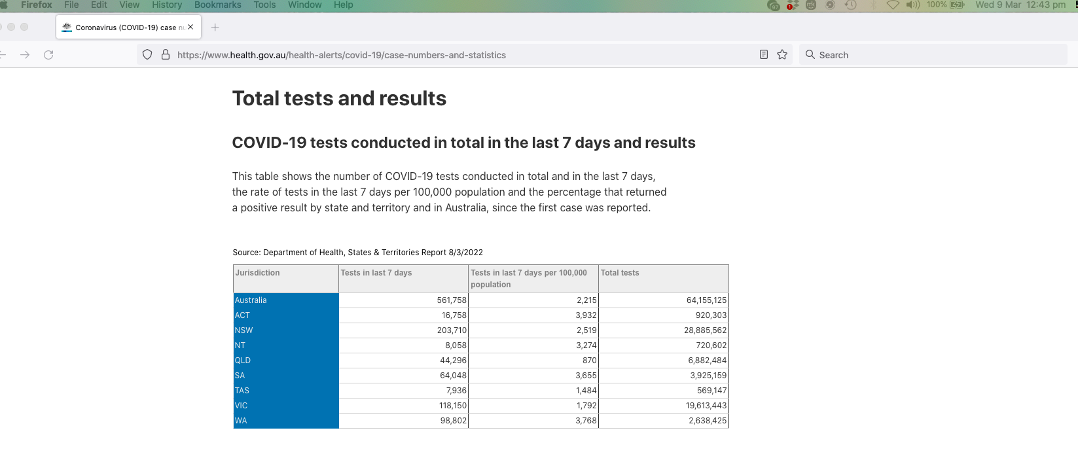

Screenshot 6 https://www.health.gov.au/health-alerts/covid-19/case-numbers-and-statistics

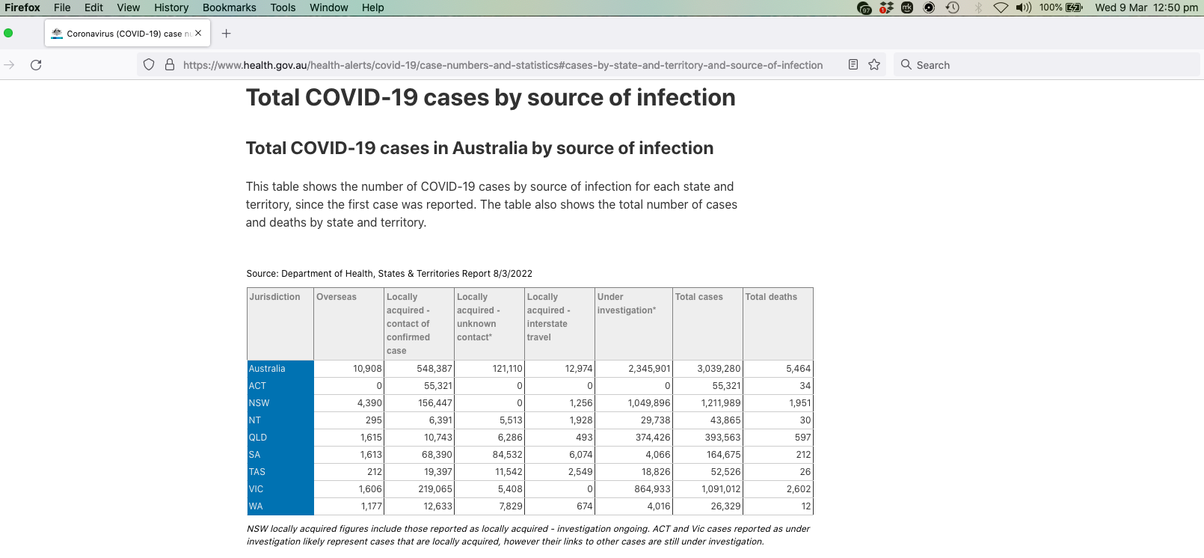

Screenshot 7 https://www.health.gov.au/health-alerts/covid-19/case-numbers-and-statistics

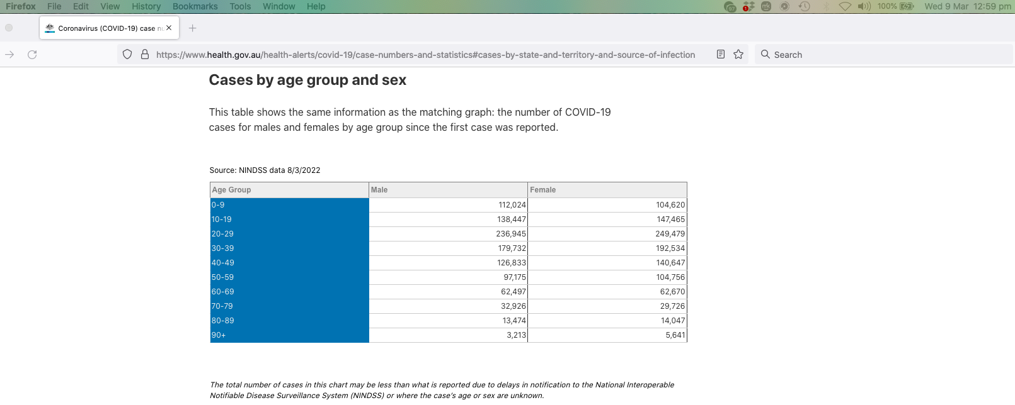

Screenshot 8 https://www.health.gov.au/health-alerts/covid-19/case-numbers-and-statistics

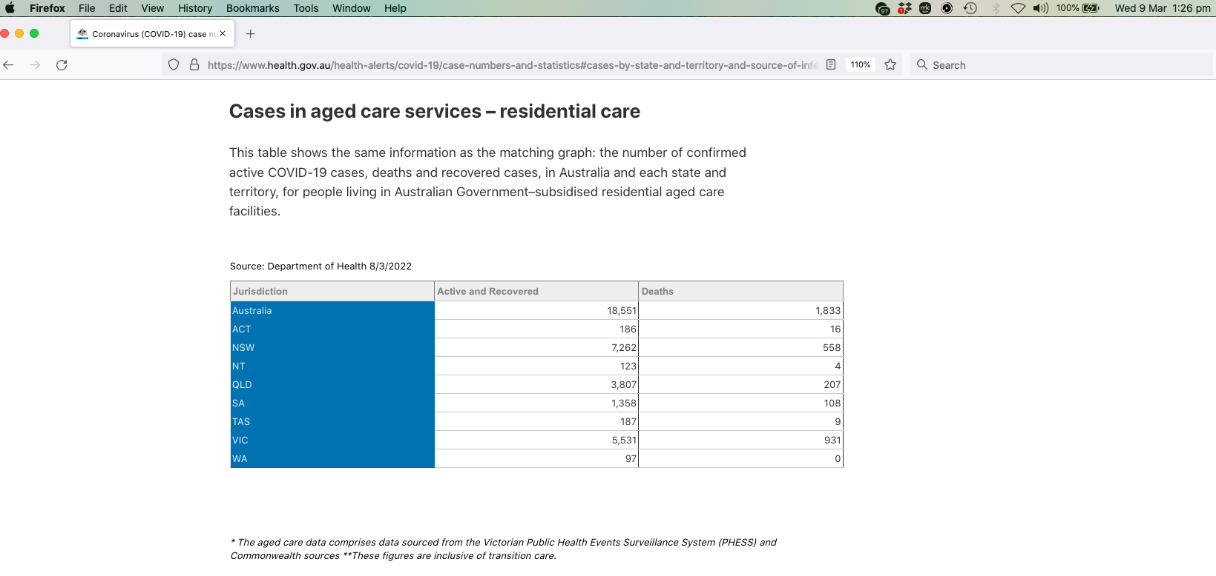

Screenshot 9 https://www.health.gov.au/sites/default/files/documents/2022/03/covid-19-vaccine-rollout-update-8-march-2022_0.pdf

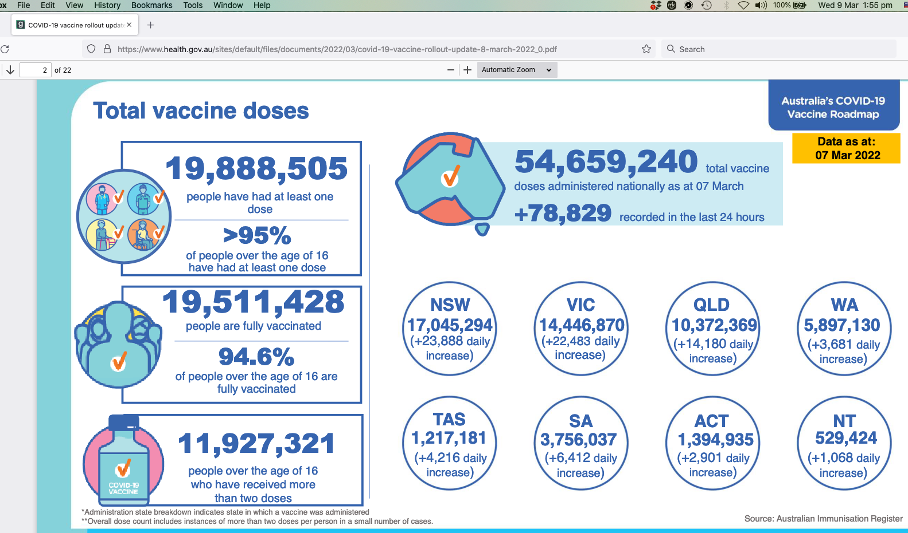

Screenshot 10 https://apps.tga.gov.au/PROD/DAEN/daen-new-search.aspx

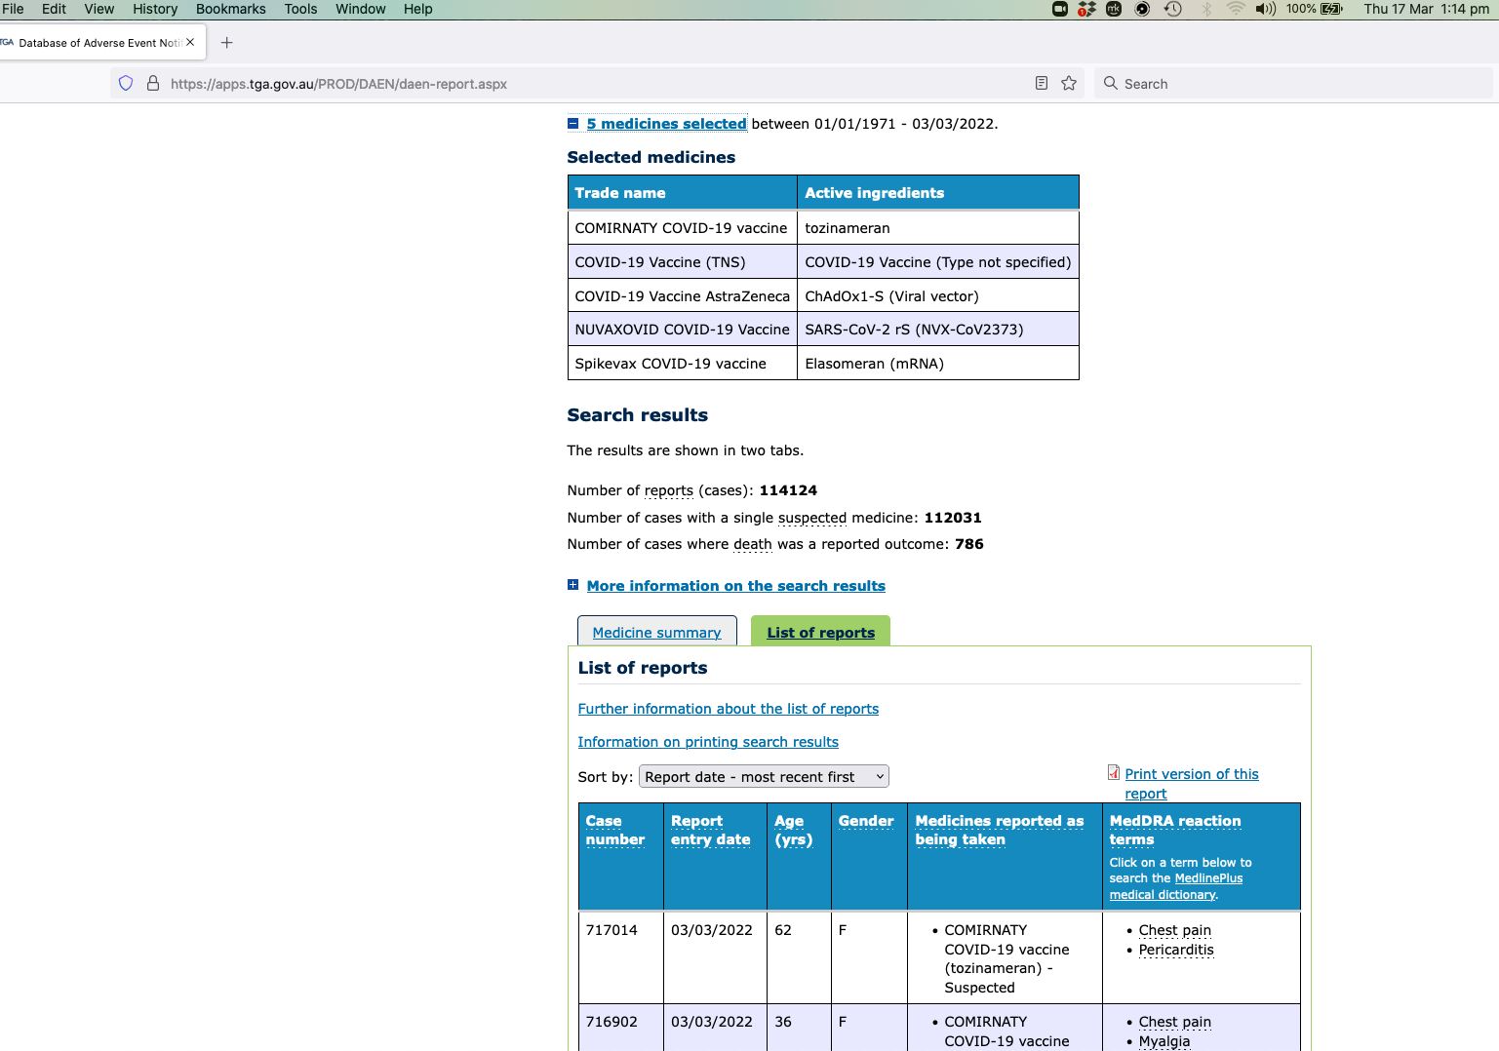
Screenshot 11 https://www.tga.gov.au/media-release/new-web-service-helps-consumer-reporting-side-effects

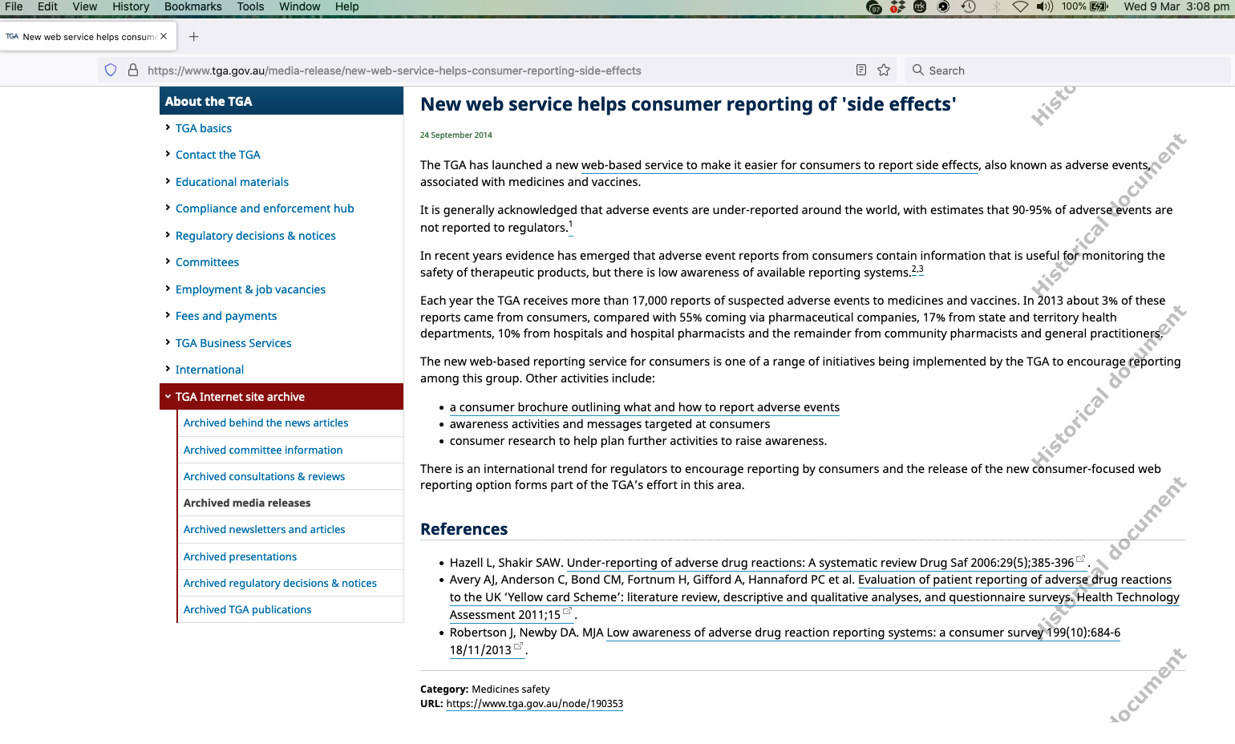

Screenshot 12 https://www.health.nsw.gov.au/Infectious/covid-19/Documents/covid-19-surveillance-report-20220120.pdf

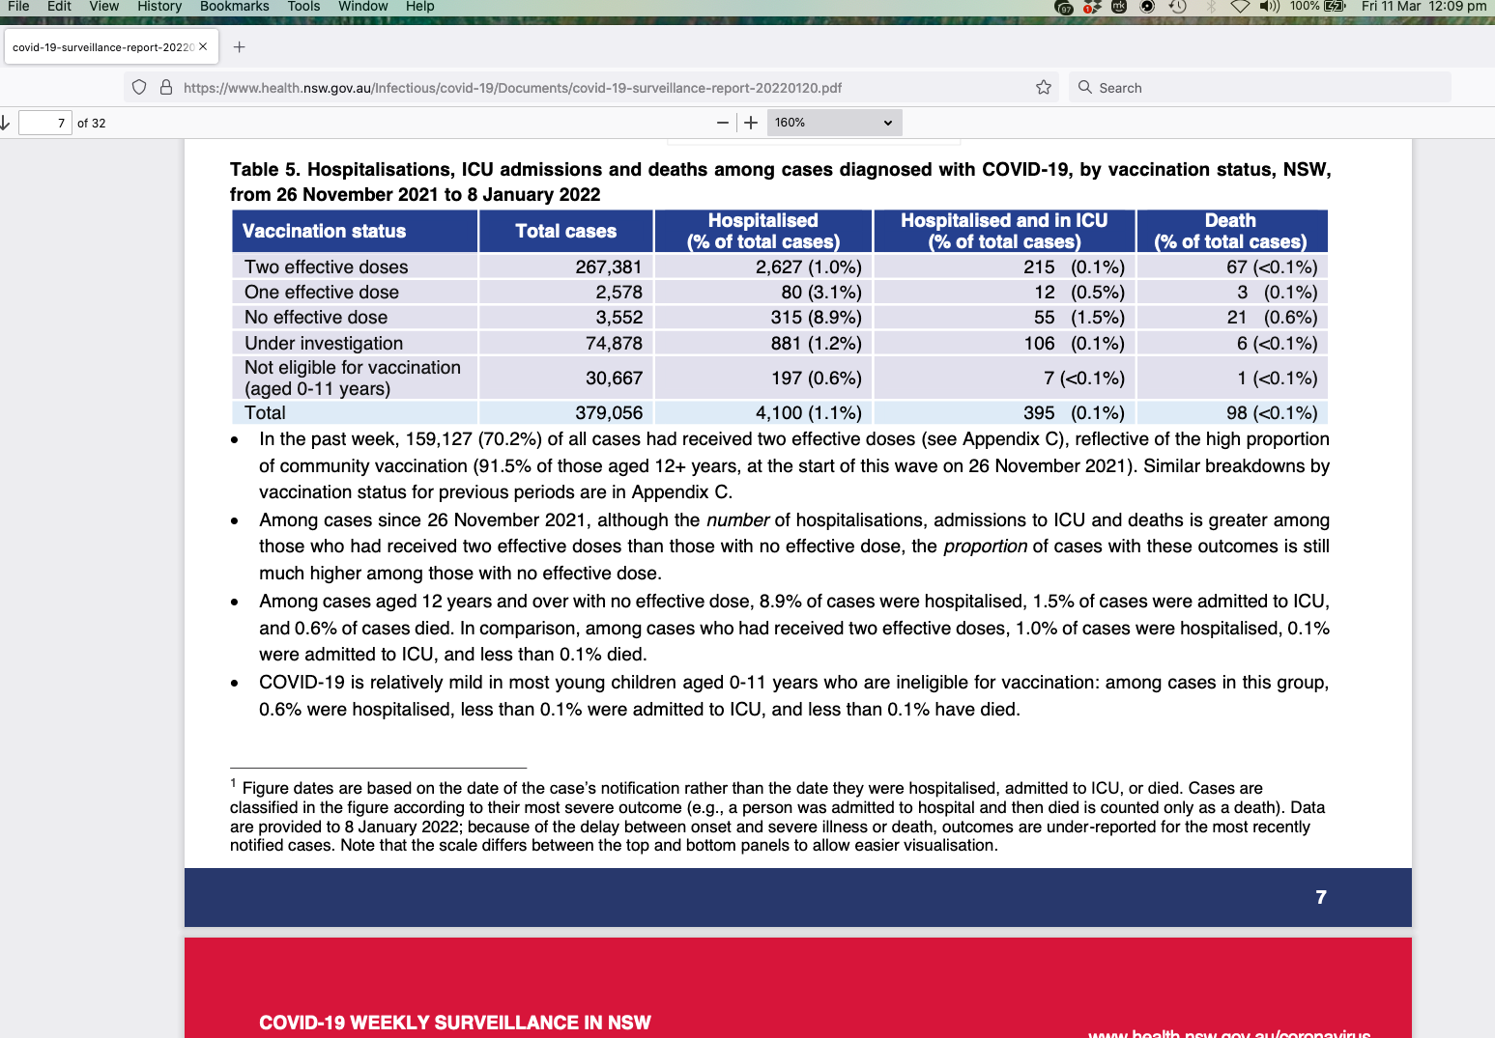

Screenshot 13 https://www.health.nsw.gov.au/news/Pages/20220311_00.aspx

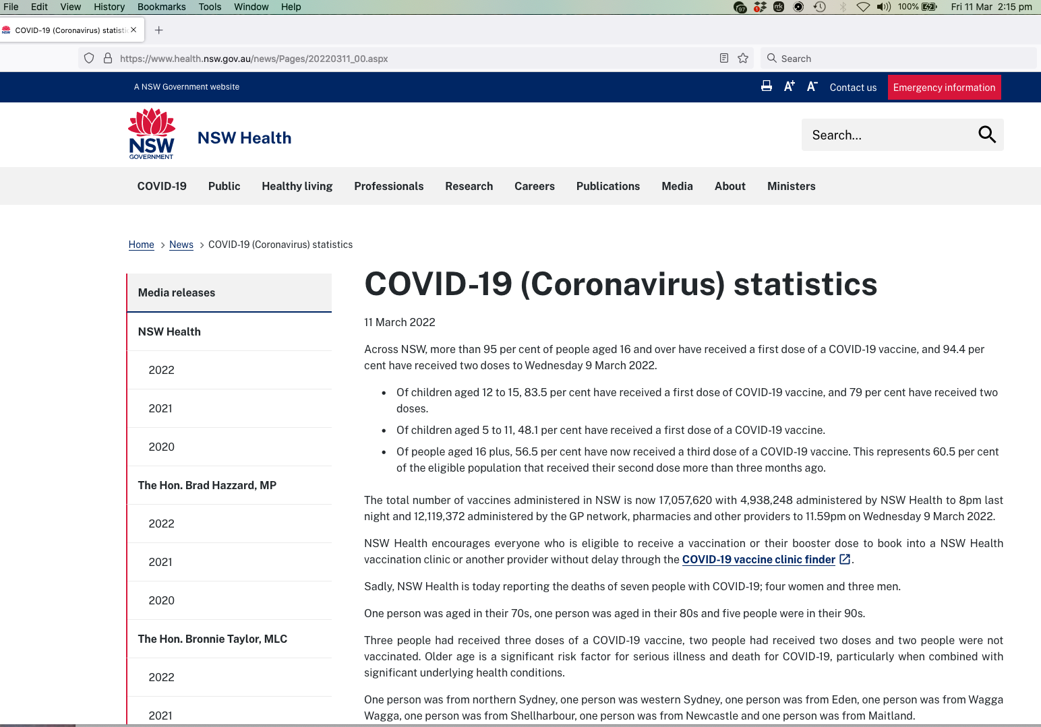

Screenshot 14 https://www.parliament.act.gov.au/__data/assets/pdf_file/0003/1562916/Chief-Health-Officer-Report-on-Status-of-Public-Health-Emergency-Due-to-COVID-19-15-June-2020.PDF

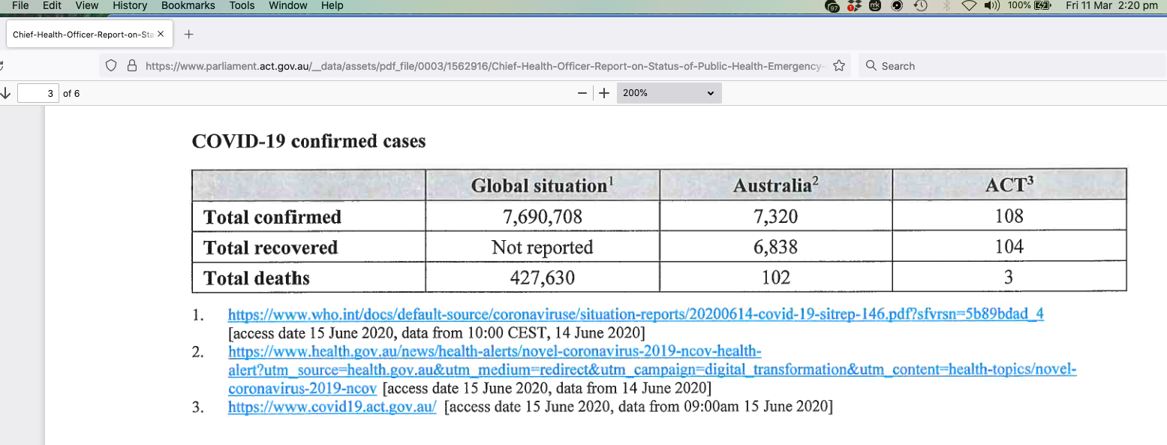

Screenshot 15 https://www.covid19.act.gov.au/__data/assets/pdf_file/0011/1964873/Weekly-epidemiological-update-1-to-6-March-2022.pdf

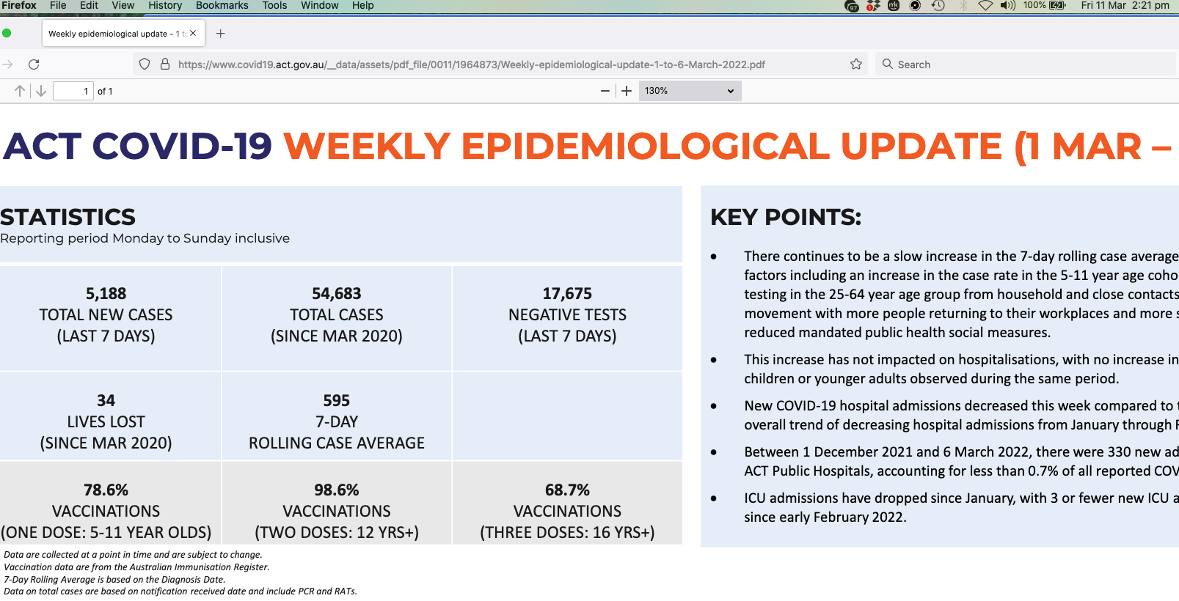

Screenshot 16 https://www.health.gov.au/initiatives-and-programs/covid-19-vaccine-claims-scheme

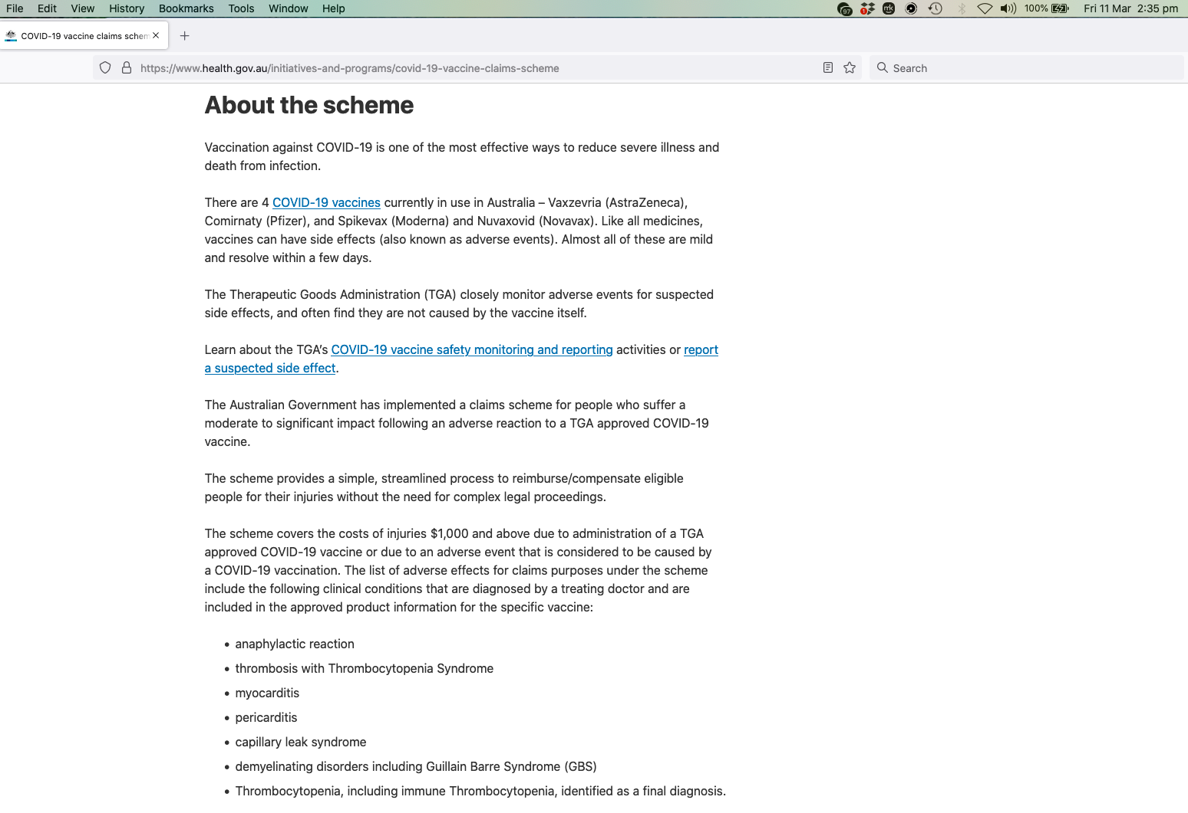

Screenshot 17 https://www.hrsa.gov/sites/default/files/hrsa/vaccine-compensation/data/vicp-stats-03-01-22.pdf

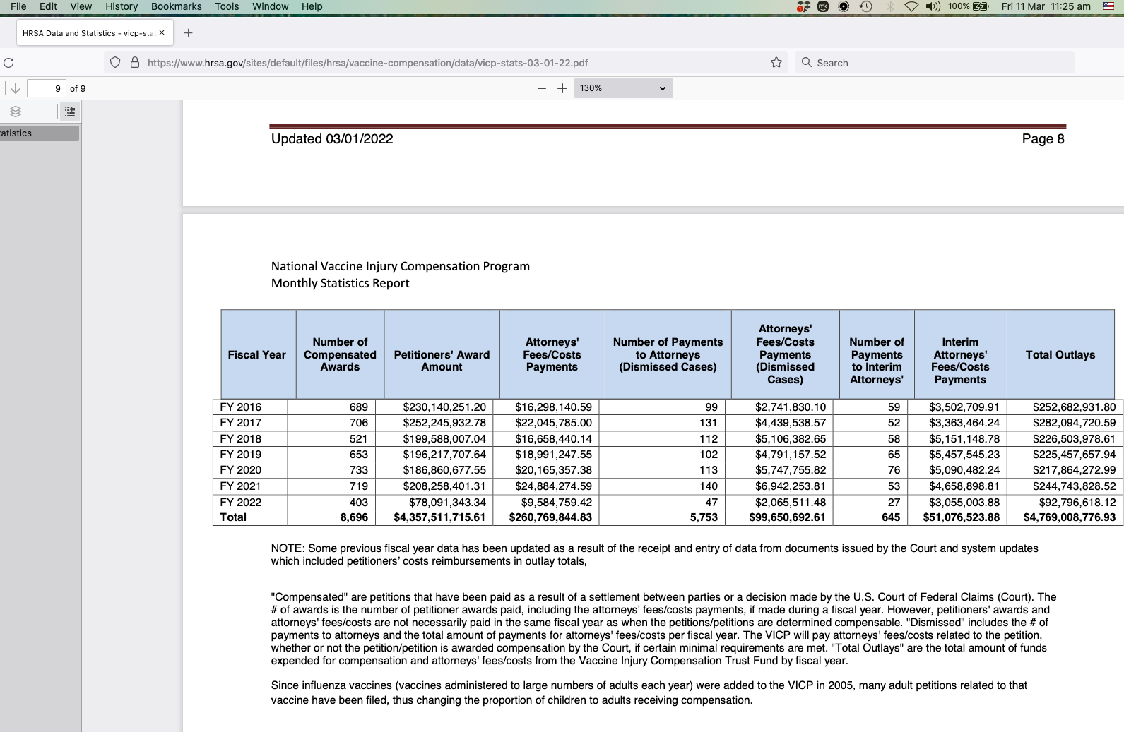

Screenshot 18 https://childrenshealthdefense.org/wp-content/uploads/5.3.6-postmarketing-experience.pdf

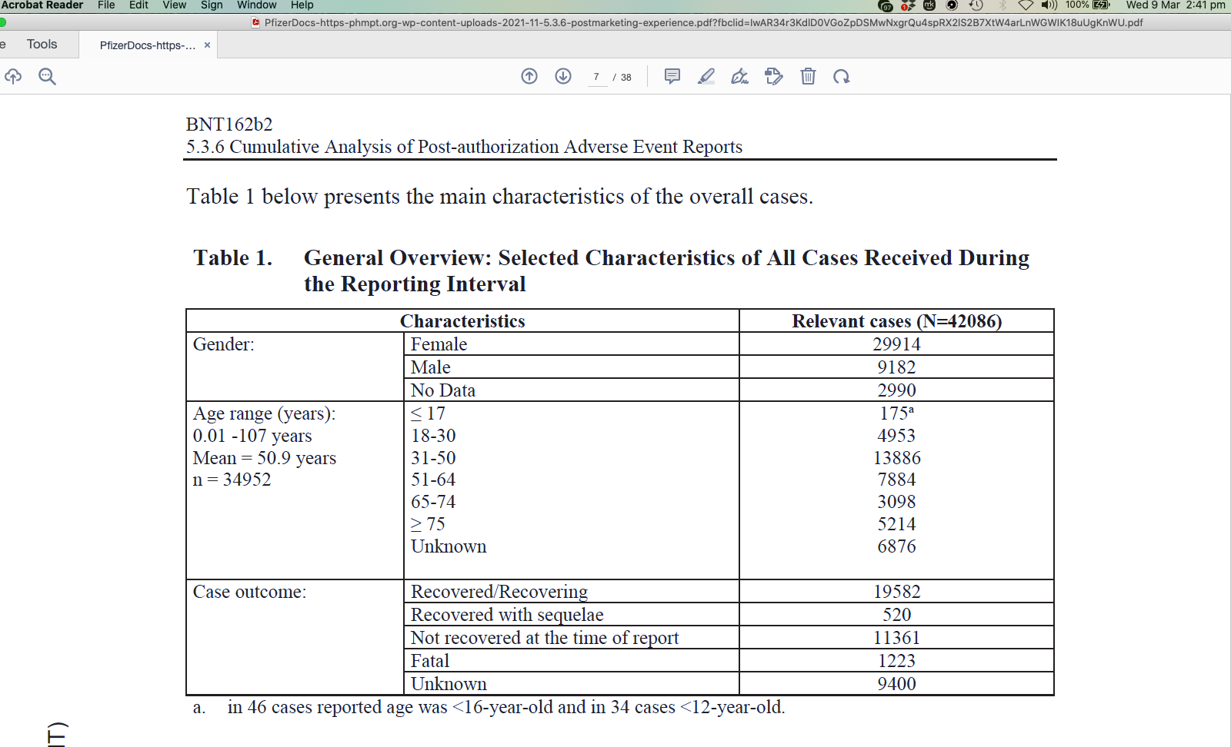

Screenshot 19 https://childrenshealthdefense.org/wp-content/uploads/5.3.6-postmarketing-experience.pdf

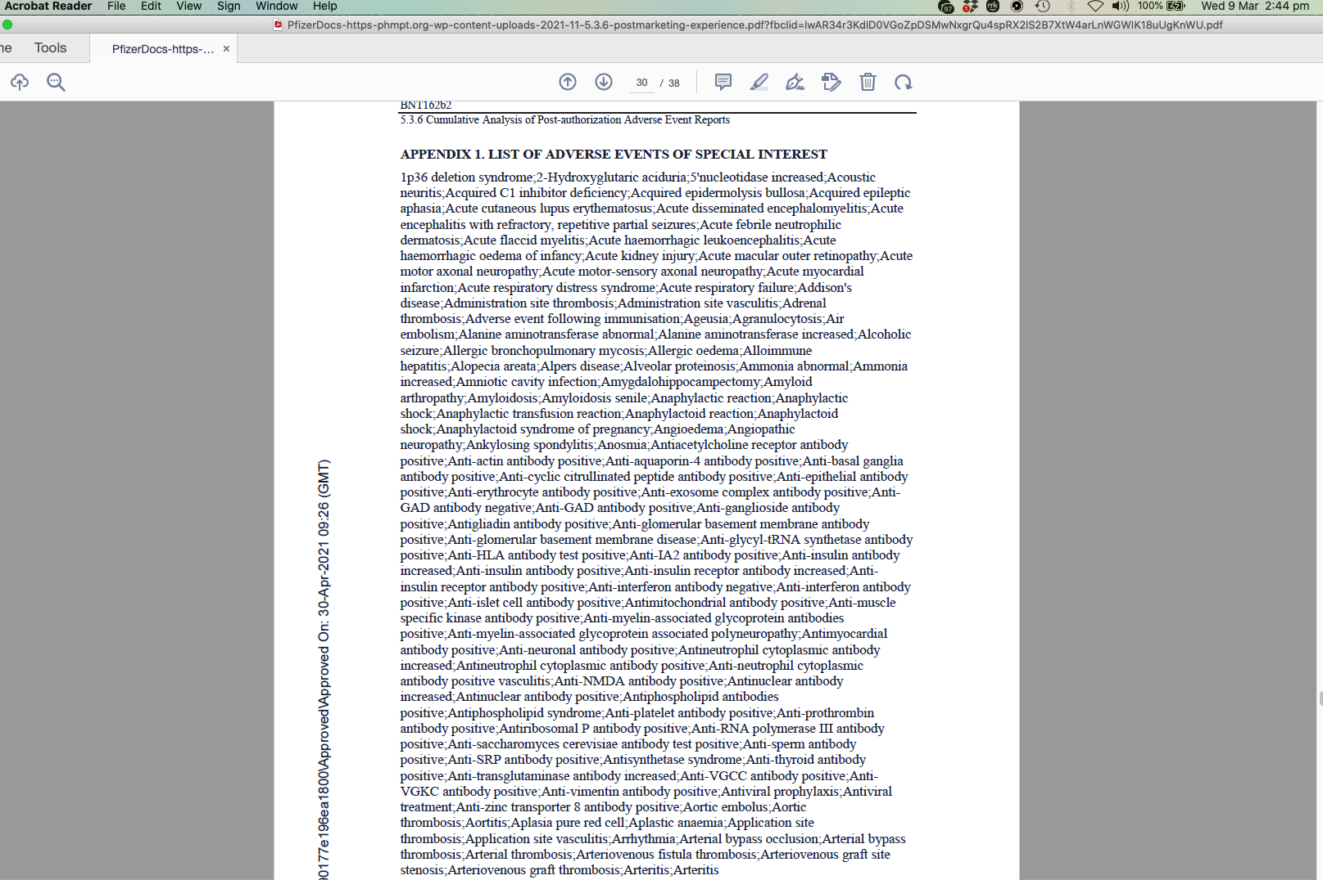
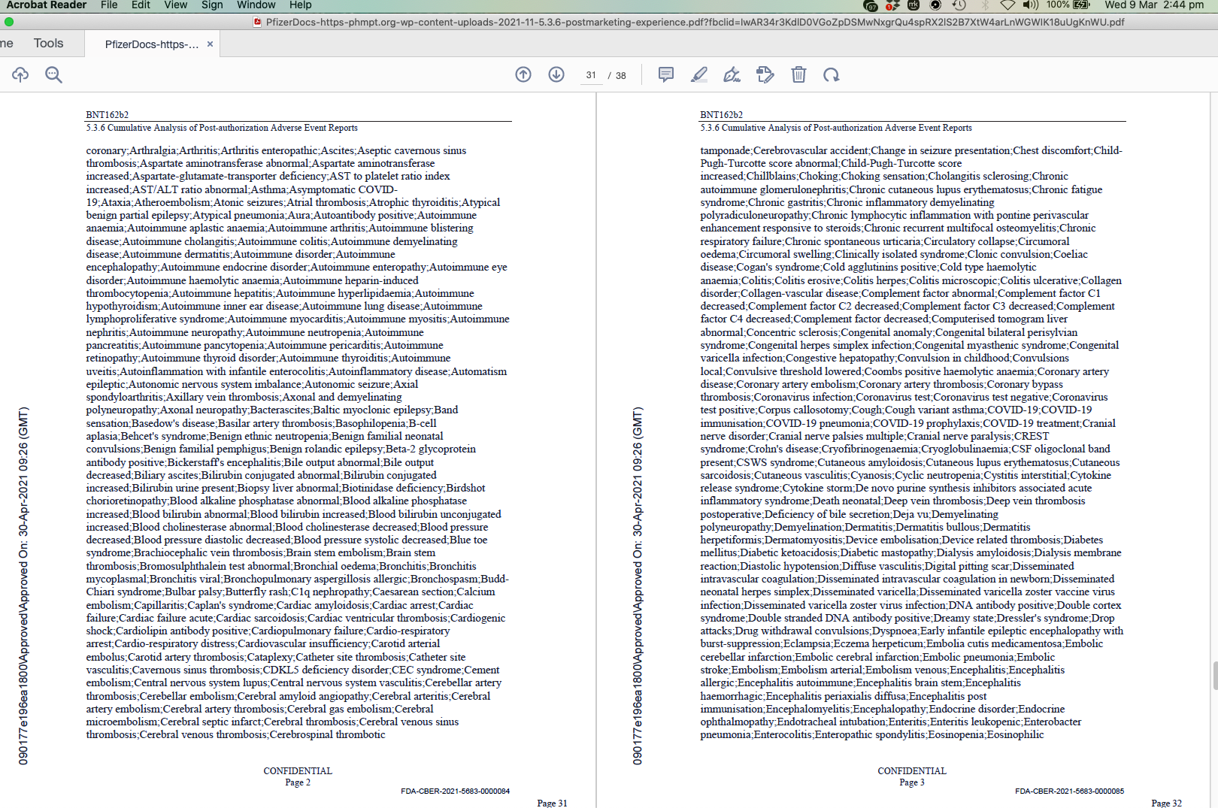
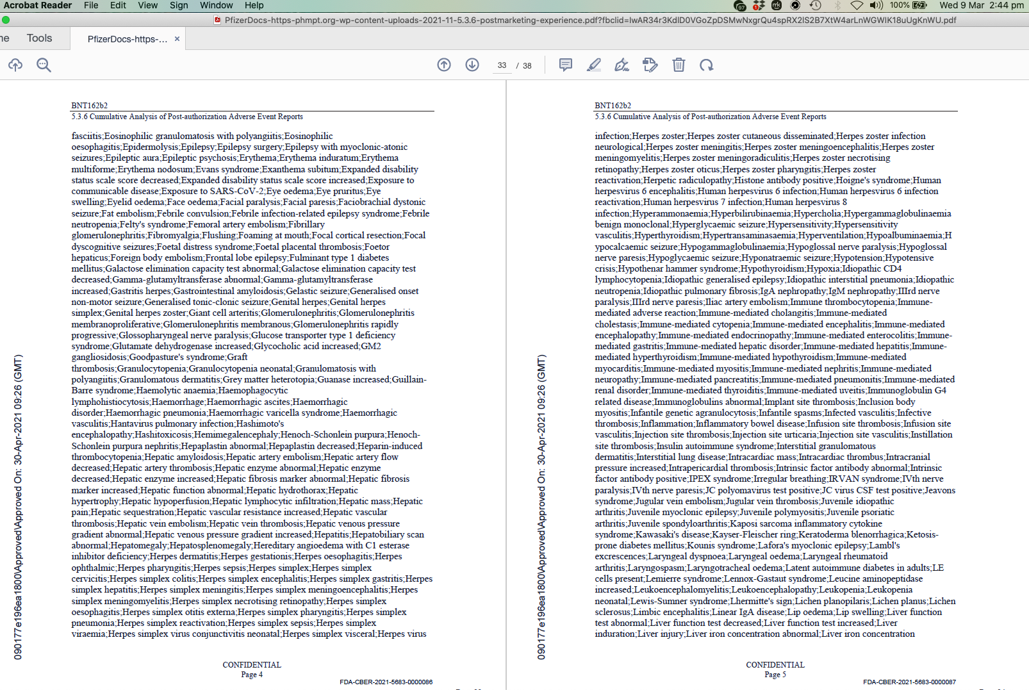
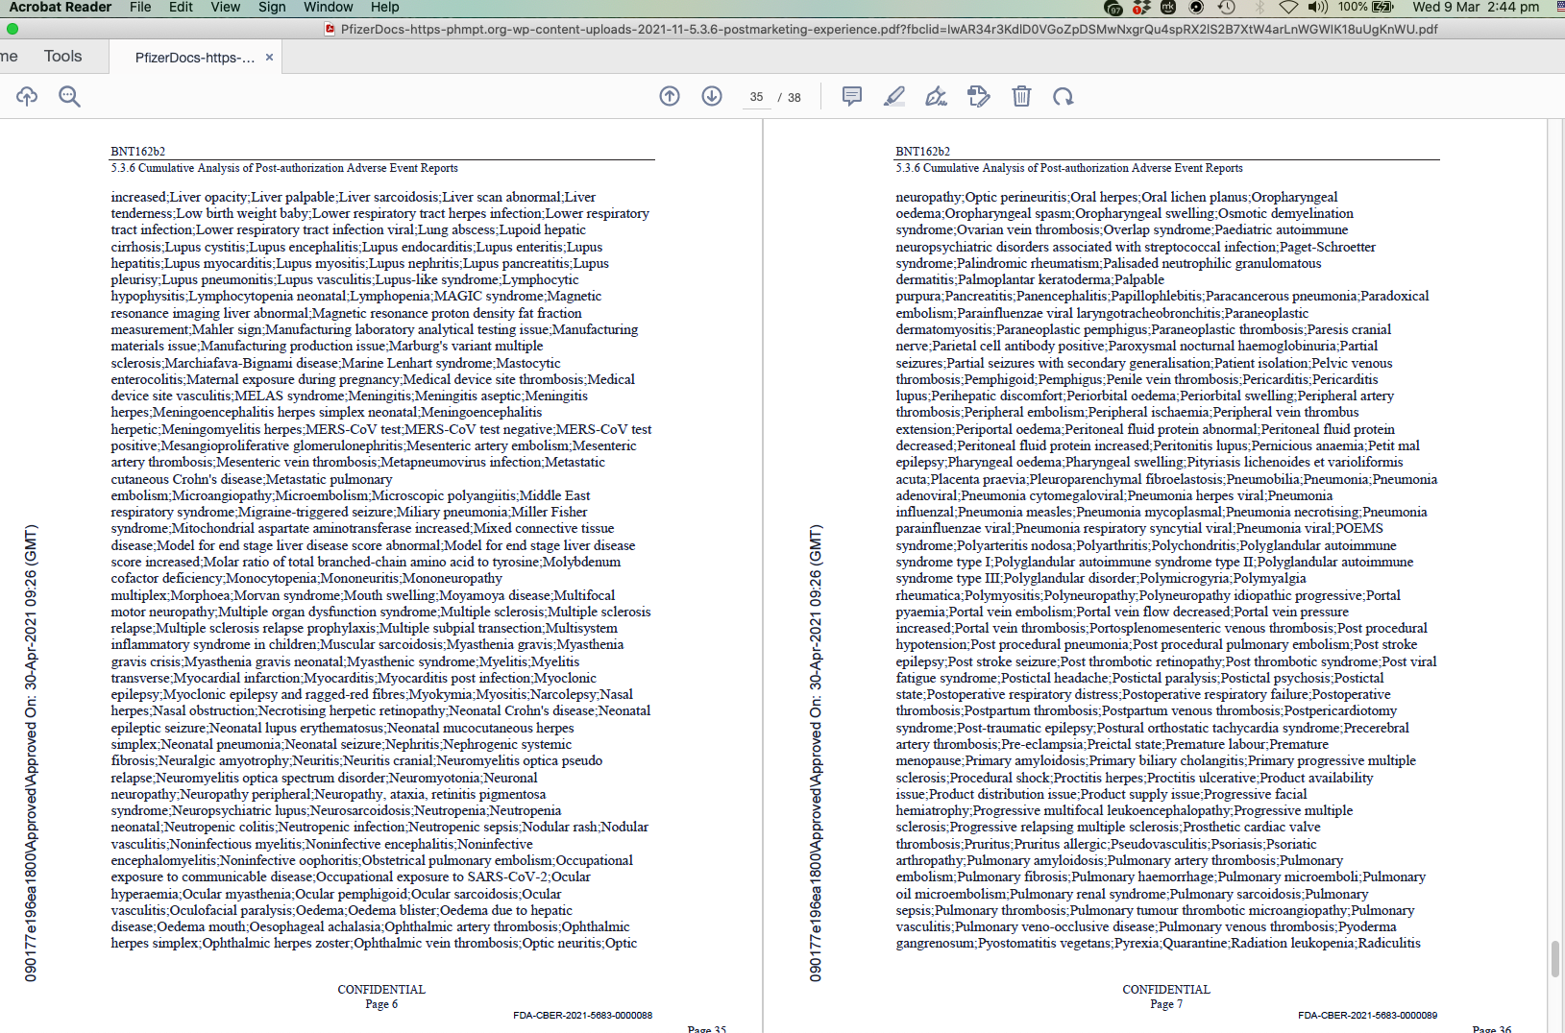
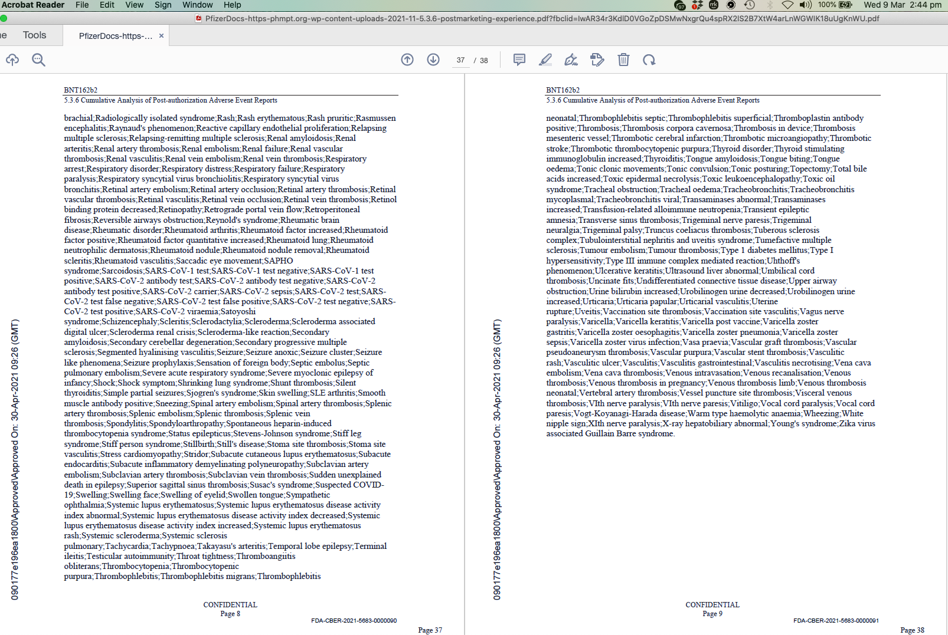
Screenshot 20 https://clinicaltrials.gov/ct2/show/NCT04368728

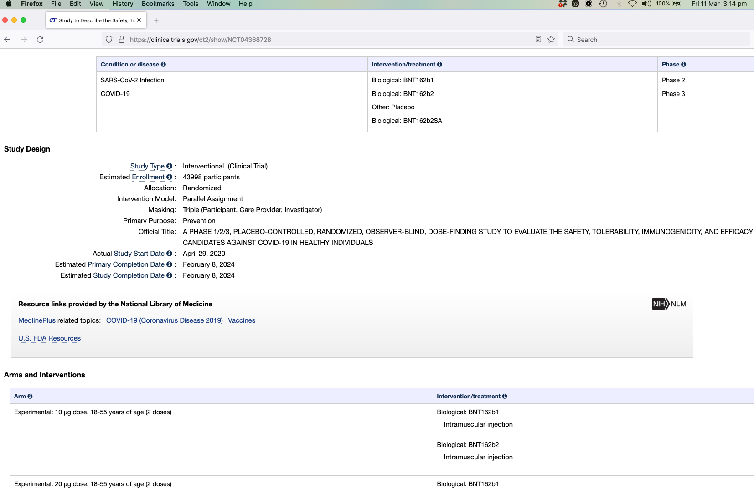

Screenshot 21 https://www.fda.gov/emergency-preparedness-and-response/coronavirus-disease-2019-covid-19/comirnaty-and-pfizer-biontech-covid-19-vaccine

